

Macau University of Science and Technology

School of Computer Science and Engineering
Innovation Engineering

Assignment No .: Chapter 2 Assignment-2025.09.09
Report Title : xxx

Student Name : xxx
Student ID : xxx
Date : xxx

summary
This project aims to design and implement a Program Evaluation and Review Technique (PERT) analysis tool in C++. This tool processes all project activities, including their dependencies and optimistic (a), most likely (m), and pessimistic (b) time estimates. The program's core functionality, based on the PERT methodology, automatically calculates each activity's expected time (te), variance (sigma²), earliest start (ES), earliest finish (EF), latest start (LS), and latest finish (LF) times, as well as slack. Ultimately, the program accurately identifies the project's critical path and calculates its total expected completion time. Testing the test.txt file successfully determined the critical path to be A→B and the total expected project time to be 5 days, validating the algorithm's accuracy and effectiveness.

Chapter 1 Introduction

1.1 Project Background
The Program Evaluation and Review Technique (PERT) is a network analysis technique widely used in project management, particularly for complex projects with uncertain activity times. It uses optimistic, most likely, and pessimistic time estimates for each activity to calculate the expected completion time of the activity and identify the "critical path" that determines the project's total duration. This project aims to develop a command-line C++ application to automate the PERT analysis process, providing project managers with fast and accurate decision support.

1.2 Development Environment
- Operating system: Windows 11
- Compiler: MinGW-w64 (g++ compiler installed via MSYS2)
- Development language: C++

Chapter 2 System Design and Implementation

2.1 Data Structure Design
To store the relevant information of each activity, a class called Activity is designed. Its instance object contains the following key properties:
- string name: The name of the activity.
- vector<string> prev: A vector storing the names of all previous activities.
- double a, m, b: represent the optimistic, most likely and pessimistic times of the activity respectively.
- double te, sigma2: calculated expected time and variance.
- double es, ef: calculated earliest start and earliest finish times.
- double ls, lf: The calculated latest start time and latest finish time.
- int slack: the calculated time difference (LS - ES).
All activities of the entire project are stored in a private member vector<Activity> activities of the PERT class.

2.2 Core Algorithm Implementation

The core calculations of the program strictly follow the standard steps of the PERT method.

2.2.1 Expected Time and Variance Calculation (calculateTeSigma2)

This step iterates over all activities and applies the PERT weighted average formula to calculate the expected time (te) and variance (sigma2).
- Expected time:
$$t_e = \frac{(a + 4m + b)}{6}$$
- Variance:
$$\sigma^2 = (\frac{(b - a)}{6})^2$$

2.2.2 Forward Calculation: Calculate ES and EF (calculateES_EF)
This step starts with the project's starting activity and calculates the earliest time for each activity in topological order.
- Early Start (ES): The earliest start time of an activity is equal to the maximum of the earliest finish times of all its predecessor activities. For a start activity with no predecessor activities, its ES is 0.
- Earliest Finish Time (EF): EF = ES + te

2.2.3 Reverse Calculation: Calculate LS and LF (calculateLS_LF)
After forward projection is completed, this step starts with the project's end activity and works backward to calculate the latest time for each activity.
- Latest Finish Time (LF): The latest finish time of an activity is the minimum of the latest start times of all its successors. For a terminal activity with no successors, its LF is equal to the earliest finish time of the entire project (i.e., the maximum of all activities EF).
- Latest start time (LS): LS = LF - te
- Time difference (Slack): Slack = LS - ES

2.2.4 Determining the Critical Path (findCriticalPath)
The critical path is a series of activities with a slack of 0. The program first finds the starting activity with a slack of 0, then uses the dependency relationships to find subsequent activities with a slack of 0, ultimately forming the complete critical path.

Chapter 3 Operation and Result Analysis

3.1 Compile and run
The code files main.cpp and PERT.cpp are compiled using the g++ compiler with the following command:
Bash

g++ main.cpp PERT.cpp -o PERT_run
The program supports reading data from files. This run uses the test.txt file, whose contents are as follows:
A,0,1 2 3
B,A,2 3 4
C,A,1 1 1

3.2 Results presentation and analysis
After the program runs, the output results clearly show the calculation process and final conclusion.
Figure 3-1 Screenshot of program running results
Detailed calculation data can be sorted out from the screenshot, as shown in the following table.
Table 3-1 Details of PER T calculation results
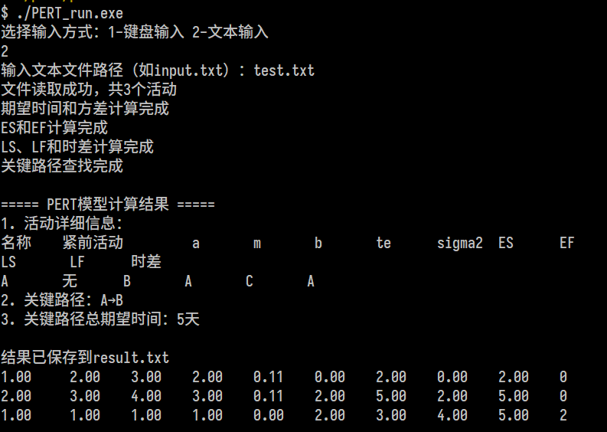
analyze:
- Critical Path: The program's calculations show that the slack between Activities A and B is 0. Therefore, the critical path is A → B. This means that Activities A and B are critical to the project's progress; delays in either activity will directly delay the entire project.
- Total project duration: The total expected time of the critical path is the sum of the expected times of all activities on the path, that is, the EF value of the last critical activity B, which is 5 days.
- Non-critical activities: Activity C has a time slack of 2. This means that Activity C has a float of 2 days and even if it is completed 2 days later than planned, it will not affect the final completion date of the entire project (5 days).

Chapter 4 Summary
This project successfully developed a fully functional PERT analysis tool using the C++ language. By leveraging object-oriented concepts, the program's structure is clear and its algorithms are accurate. Test results demonstrate that the program correctly reads project activity data, accurately calculates various PERT parameters, and ultimately determines the project's critical path and total expected duration. The implementation of this tool not only deepened our understanding of the PERT project management methodology but also strengthened our C++ programming and algorithm design skills.

Reference
- LeCun, Bengio, Y. and Hinton, G. (2015). Deep learning. Nature (London), 521(7553), 436–444. https://doi.org/10.1038/nature14539 .
- B. Chen and J. Zhang, "Tuple density: A new metric for combinatorial test suites," in Proceedings of the 33rd International Conference on Software Engineering (ICSE'11) , 2011, pp. 876-879.
- A. Arcuri and L. Briand, “Formal Analysis of Interaction Fault Detection Probability Using Randomized Testing,” IEEE Transactions on Software Engineering , vol. 38, no. 5, pp. 1088-1099, 2012.
- G.J. Myers. The Art of Software Testing. John Wiley & Sons: New York, 2004.
- "Keras: A Python Deep Learning Library", 2020, https://keras.io3 .
- "scikit-learn, Machine Learning in Python", 2020, https://scikit-learn.org/stable/ .

